Hill & Dale District
Presents

“Different Times, New Ideas”

A Virtual Flower/Design Show

Tuesday, May 28, 2020
Admission is free and open to the public

District Website
Hillanddaledistrict.weebly.com

Member of National Garden Clubs Inc
Pacific Region Garden Clubs Inc
Washington State Federation of Garden Clubs
Hill and Dale District of Garden Clubs
9 Clubs
172 Members

General Rules

Show Theme: “Different Times, New Ideas”

Eligibility: Any member of Hill & Dale District

Advanced Entries: Not necessary, anyone can enter, limit of one in each class for horticulture unless a different named variety or color.

Entry Time: Enter by May 20th, 2020. Please email all entries to kathyj16@msn.com start sending your pictures now; you do not have to wait until May 20th to send.

Entry Tags: Entry tags are not needed. When you submit your entries (in email form) please include the following information below. Your club will receive points for all of your entries.
Your Name
Name of your club
What Section & what Class number, for example a Rose Floribunda, would be Section A Class 3a
Name of flowers, also include the botanical name for horticulture entries

How to Take Your Pictures: Start taking pictures of your flowers now—Different Times, New Ideas. Have you ever wanted to enter a lovely flower or flowering branch but did not want to cut it, well now you do not have to. Just put white paper or some other white item (white foam board, or poster board) behind your flower or branch and snap away!!!! For your cut horticulture, please use white paper behind and underneath your clear bottles. Please see examples below.
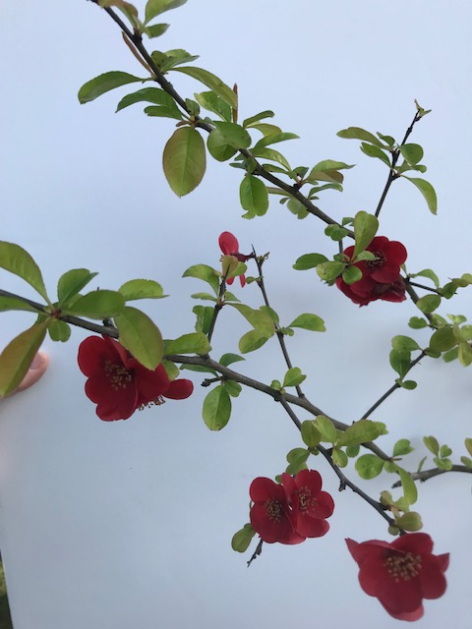

Judging Time: This show will not be judged, it’s for your enjoyment only
Viewing Time: May 26th, 2020 on our district website log into hillanddaledistrict.weebly.com
or go to Goggle and enter Hill and Dale District Garden Clubs

Horticulture Sections and Classes
Division I
“What’s In Your Garden?”

Section A. “Stake Them Up”
Class 1. Iris (I stem, one flower scape with at least one open flower)
a. Bearded
b. Beardless
c. Japanese Iris
Class 2. Paeonia (Peony, single stem)
Class 3. Rosa
a. Floribunda
b. Grandiflora
c. Hybrid Tea
d. Any other worthy named rose

Section B. “Bunches Of Spring”
Perennials & Biennials

Class 4. Aquilegia (Columbine 1 stem)
Class 5. Chrysanthemum
Class 6. Viola (Pansies 3 stems, same variety, same color)
Class 7. Zantedeschia (Calla Lily)
Class 8. Any other worthy named perennial/biennial in bloom 1 stem

Section C. “Branching Out”
Evergreen Flowering Shrubs and Trees
1 branch not over 24” must be in bloom

Class 9. Camellia (single bloom with 1 to 2” stem with at least 1 leave attached, exhibit in a bowl )
Class 10. Ceanothus (Evergreen Lilac )

Class 11. Rhododendron (one truss on stem with attached foliage)
a. Azaleas (1 spray)
Class 12. Any other worthy named evergreen flowering shrub,tree

Section D. “Out On A Limb”

Deciduous Flowering Shrubs and Trees
1 branch not over 24” must be in bloom

Class 13. Cercis (Red Bud)
Class 14. Cornus (Dogwood)
Class 15. Malus (Flowering Crabapple)
Class 16. Kolkwitzia amabilis (Beauty Bush)
Class 17. Paeonia tree (Peony)
Class 18. Spiraea
Class 19. Syringa (Deciduous Lilac)
Class 20. Viburnum
Class 21. Any other worthy named deciduous flowering shrub,tree

Section E. “Different Times, New Ideas”
Class 22. Garden Bouquets, Containing at least 5 cut flowers
- Single variety
- Mixed variety
Class 23. Patio Planters
- Single variety
- Mixed variety
- Sedums and Succulents
Class 24. Hanging Baskets
- Single variety
- Mixed variety

Design Sections and Classes
Division II
“What Will May Bring?”

Section A “May Flowers”
Class 1. Future times — Transparency design
Class 2. Different times — Abstract design
Class 3. New ideas — Multi Rhythmic design
Class 4. Moon light nights — Reflective design
Classes staged on a 27” x 30” space of a 6’ table, draped in white, with a white wall behind.

Section B “Mothers Day”

Class 5. Mothers Day design — Designers choice
Class 6. May baskets — Designers choice using a basket
Class 7. Dancing around the Maypole — Multi Rhythmic design
Class 8. Different Times, New Ideas — Designers choice
Classes staged on a 27” x 30” space of a 6’ table, draped in white, with a white wall behind.

Designs are open to all members, with no advance entries registration necessary. While staying home please try a design. Let us know if you are a novice (new) at designs. A novice is a designer who has won no more than 5 blue ribbons for designs. Different Times, New Ideas.

Botanical Arts Sections and Classes
Division V
“Our Garden Snapshots”

Section A “What’s Your Life Look Like?”
Class 1 Crazy Times – collage
Class 2. Organized Times – plaque
Size should be 8.5 X 11, with the picture taken in upright position like on an easel

Section B “What’s In Your Yard?”
Class 3. Feed the birds – bird houses, birdbaths ect…
Class 4. Garden art – fun things in your yard
Class 5. Garden tour – your home gardens

Photo’s may be either landscape or portrait
Photographs do not need to be mounted on black mat

Glossary of Terms

Abstract Design — A design where all components need not be abstracted, however there should be a dominance of abstraction. Plant material and other optional components are selected, treated and or organized in a non-naturalistic manner.

Collage – is an abstract design created on a background panel/s with a dominance of components attached in a non-realistic arrangement. Components include plant material and other found objects. Staged in upright position.

Designer’s choice – A type of design that the designer chooses. Designer has complete freedom in all components and plant material types, like fresh, dried or a combination of both materials.

Multi-Rhythmic Design — A creative design with emphasis on two (2) or more rhythms in the design with one (1) rhythm dominating. Lines create two (2) or more separate and distinct rhythms, each creating a different pattern and movement unlike the other. Lines may go in any direction, be continuous, interrupted
and /or crossed.

Plaque — a design organized in a naturalistic manner composed of plant material and other optional components attached to a background panel/s serving as the frame of reference. Staged in upright position

Reflective Design — A creative design containing reflective material giving back images of light to the viewer. The reflective materials are an integral part of the overall design. Staging in front or on a mirror is not acceptable.

Transparency Design — A creative design with see-through elements (translucent, diaphanous, grid-like materials, etc.) integral to the design and permitting some components to be viewed through others.

